**UNIKLCTF 2020**

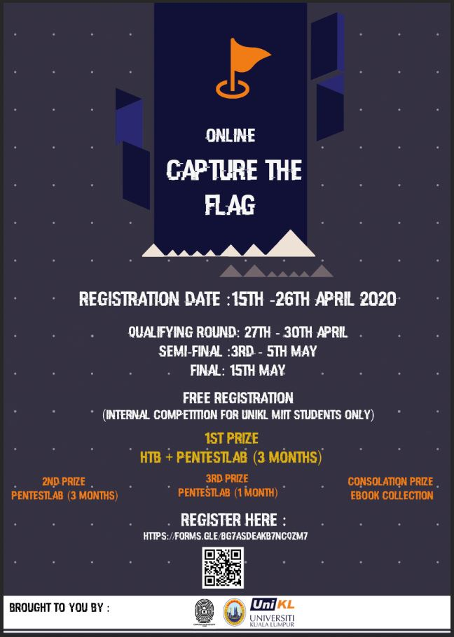

**Team_Gardenia**

**Table of Contents**

**1.** **WEB** 3

1) News Portal 1 (20) 3

2) News Portal 2 (20) 6

3) PASSTHRU (40) 7

**2.** **REVERSE** 10

1) UNLOCK ME! (40) 10

**2)** **STEGANOGRAPHY** 12

1) MEME OF THE YEAR (10) 12

2) ULALALA (10) 14

3) SEE THE WORLD (40) 15

**3)** **FORENSIC** 23

1) DO YOU WANT TO BUILD A SNOWMAN? (10) 23

2) KESANA KESINI (20) 24

3) VPC LOG ANALYSIS (20) 27

4) PKP MALAYSIA TERBAIK! (40) 31

**4)** **MISC** 34

1) DROP THE BEAT (10) 34

2) VIRAL MESSAGE!! (10) 37

3) FINDING A SECRET MESSAGE (20) 39

**4)** **CRYPTO** 41

1) EASYCRYPTO (10) 41

2) YANG PATAH TUMBUH YANG HILANG BERGANTI (10) 42

3) WHAT HAPPEN TO MY FLAG (20) 43

# **WEB**

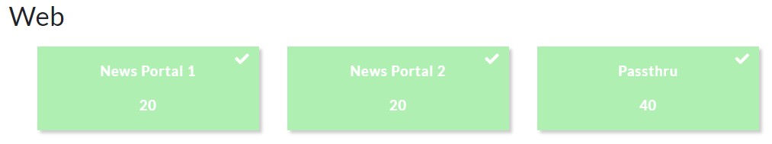

## News Portal 1 (20)

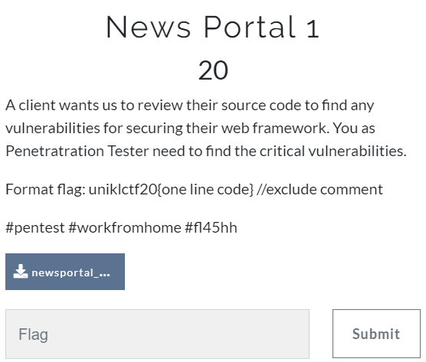

First questions for web is News Portal for 20 marks. The downloaded files give us a website file and sql file.

So, I upload the sql file into phpMyAdmin.

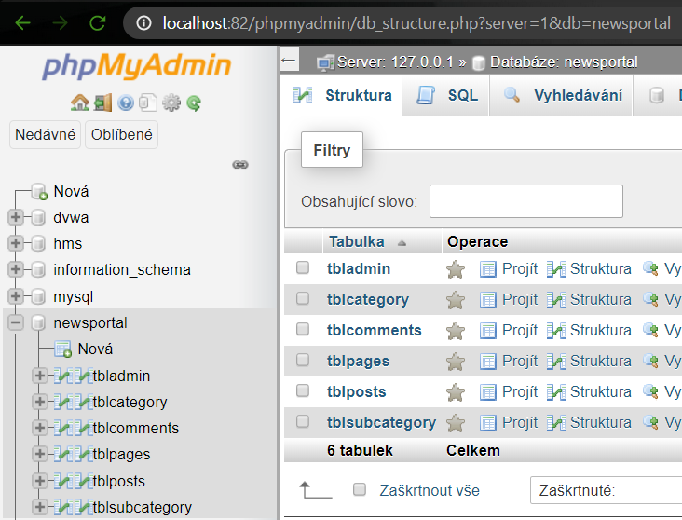

We are present with this website.

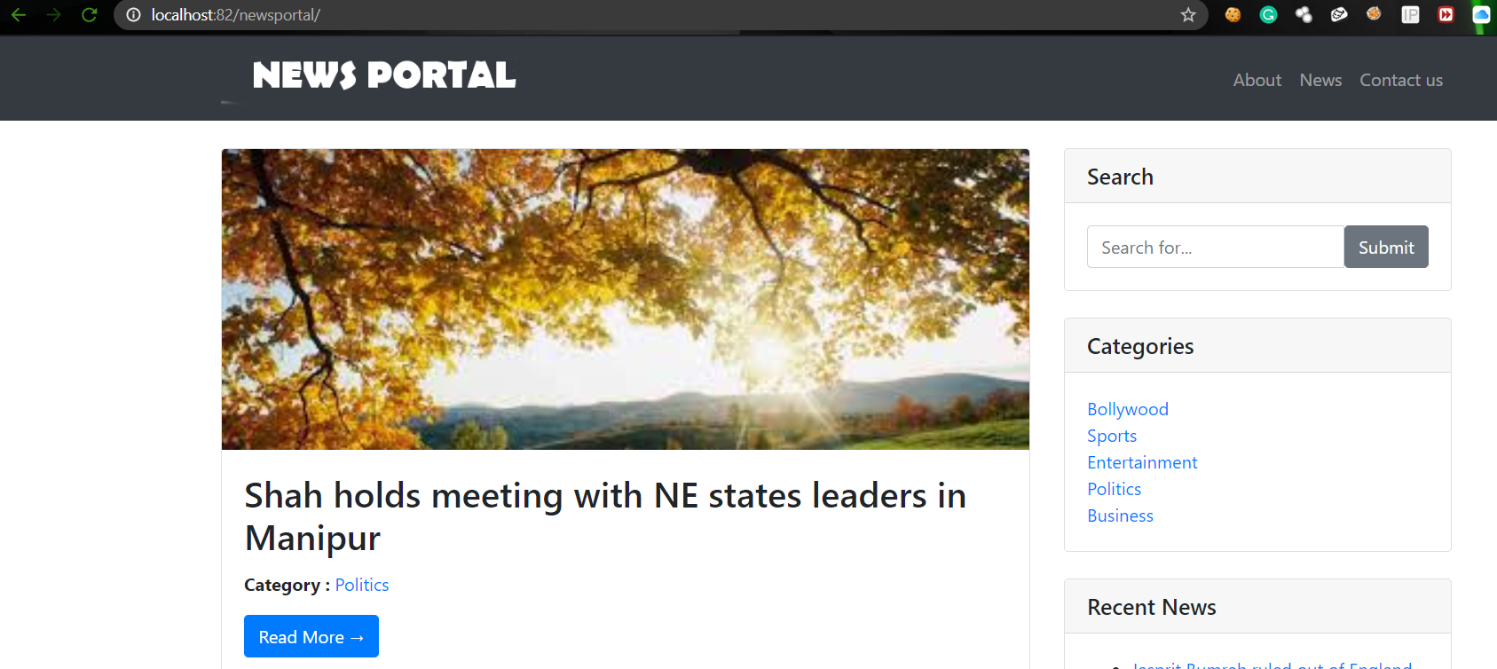

Hint that they give us is

* **Critical vulnerabilities**

We see there is search box. What were we waiting for? Go for SQL Injection or XSS of course.

Search for SQL Injection code cheat sheet. (I use very simple one, ' or '1'='1)

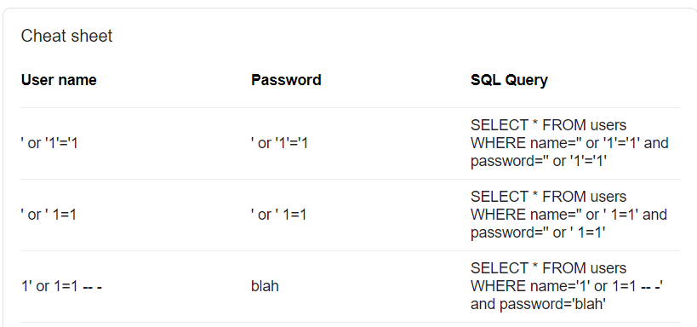



Here we present the critical vulnerabilities :

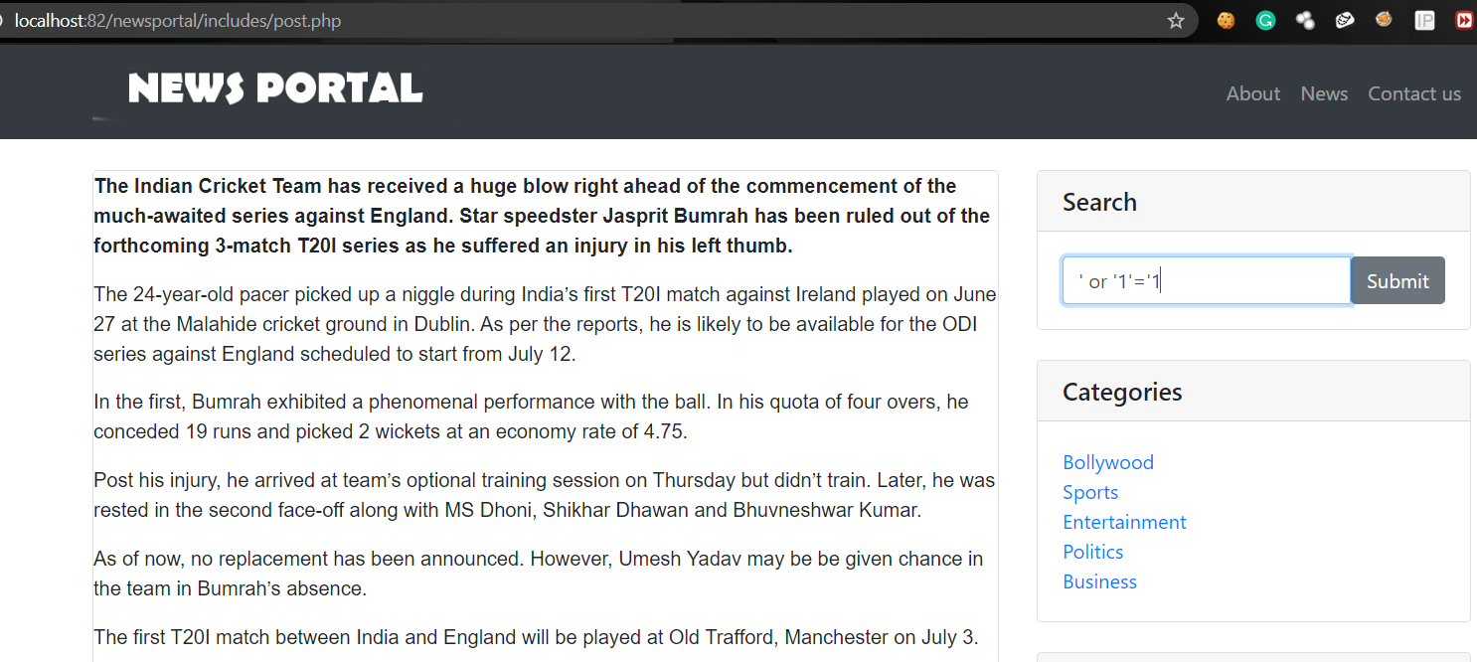

Without wasting time, we find the source code and find where SQL called for the text box.

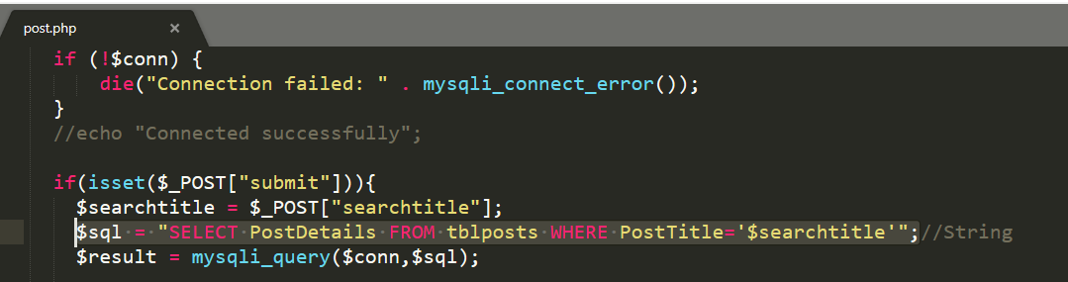

So, we take that one line code -Without a string-



**uniklctf20{$sql = "SELECT PostDetails FROM tblposts WHERE PostTitle='$searchtitle'";}**

## News Portal 2 (20)

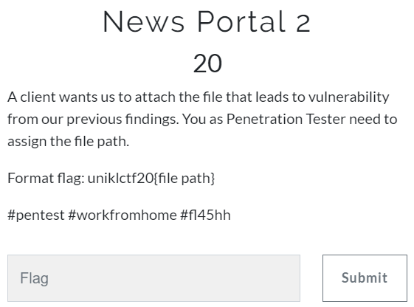

Just take the path to where the code we take earlier.



**uniklctf20{/newsportal/includes/post.php}**

## PASSTHRU (40)

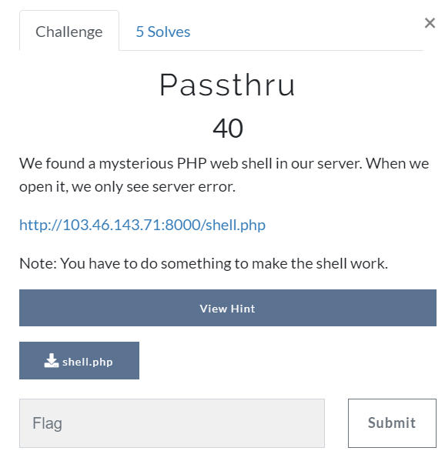

Our last questions for web are Passthru.

The downloaded file just gives us one-line php code.

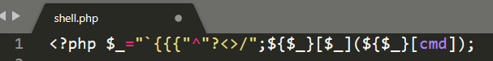

And the link given in the challenge, show us error.

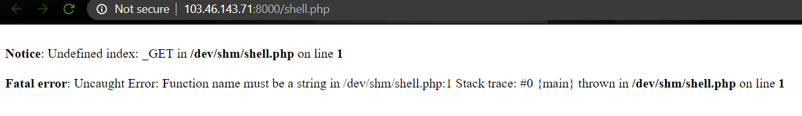

<http://103.46.143.71:8000/shell.php>

This is so new for me.



Googling skill show me this.

* <https://www.acunetix.com/blog/articles/web-shells-101-using-php-introduction-web-shells-part-2/>

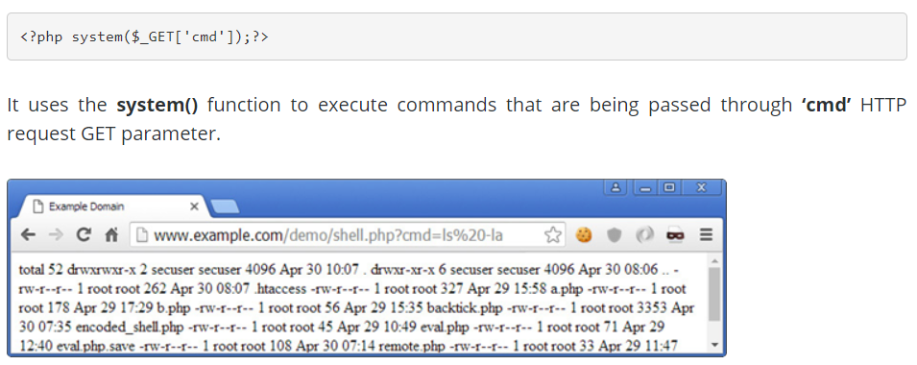

Which I think to try it out.



It took me forever to get a right thing.

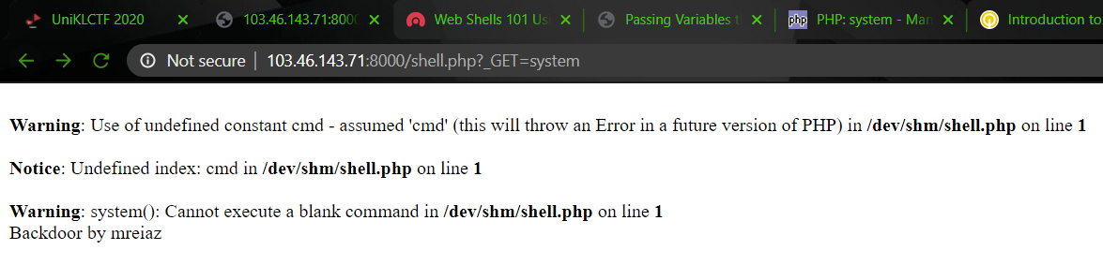

<http://103.46.143.71:8000/shell.php?_GET=system>

When I try _GET=system, it shows some difference and it said about CMD.

So, again GOOGLE how to combine _GET=system and CMD command.

I found it that it just needs “&”

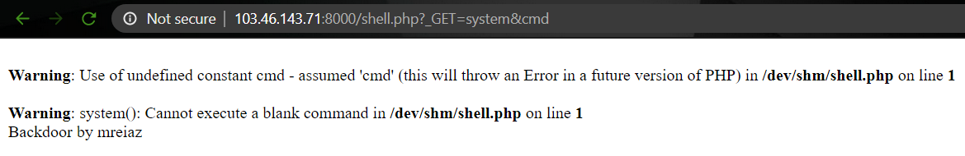

<http://103.46.143.71:8000/shell.php?_GET=system&cmd>



To see what inside I try to ‘ls’ in the cmd.



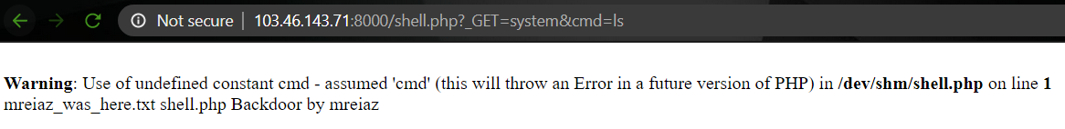

<http://103.46.143.71:8000/shell.php?_GET=system&cmd=ls>

mreiaz_was_here.txt

* Cat mreiaz_was_here.txt

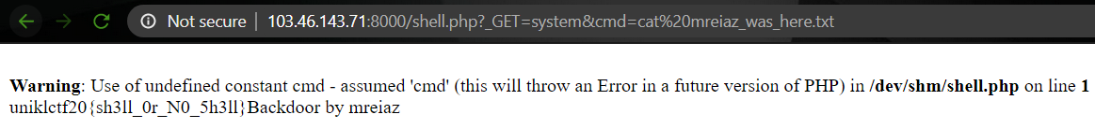

<http://103.46.143.71:8000/shell.php?_GET=system&cmd=cat%20mreiaz_was_here.txt>



**uniklctf20{sh3ll_0r_N0_5h3ll}**

# **REVERSE**

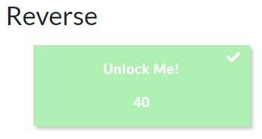

There is only one challenge for Reverse.



## UNLOCK ME! (40)

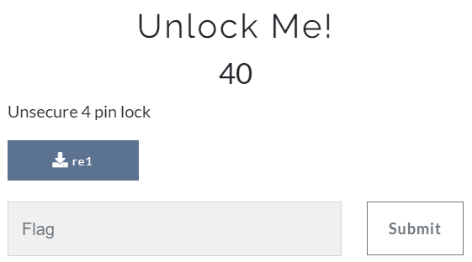

Very straight challenge with 40 marks.



* We download IDA Pro Demo
* FN + F5 – give this code to us.

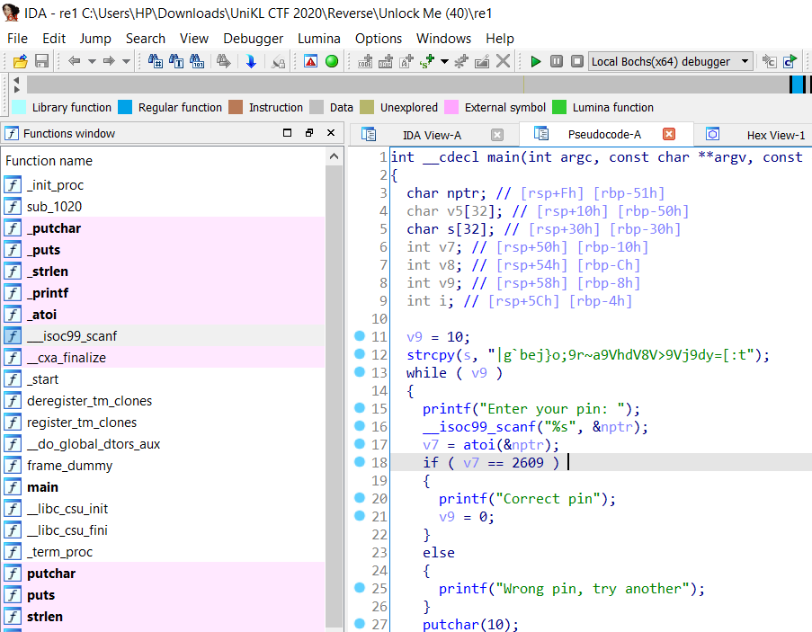

* Between “Enter Your Pin” and “Correct Pin” there is “Unsecure 4 pin”
* Run re1 and enter the pin



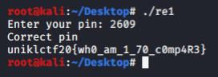



**uniklctf20{wh0_am_1_70_c0mp4R3}**

# **STEGANOGRAPHY**

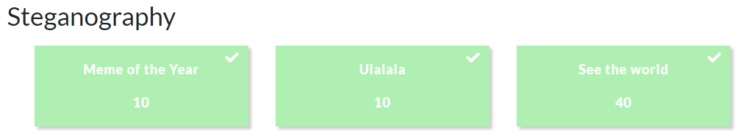

## MEME OF THE YEAR (10)

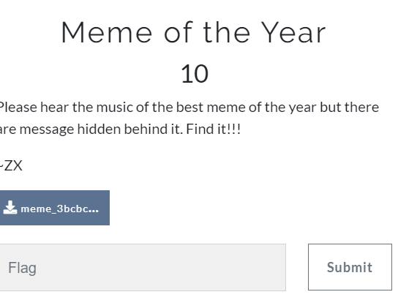

Download the file. Which is a mp3 file. Music of Coffin Dance.



When you play the music, you will hear the “hurshhh” sound at some point of the mp3.

Open it with Audacity. Inspect with “Spectrogram”



At early of the music.

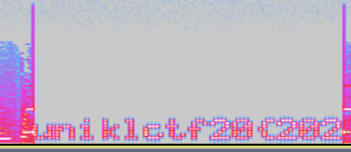

At the end of the music.

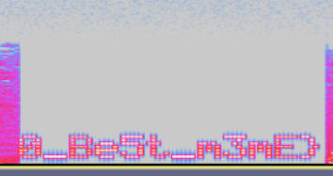

Combine all the flag part.



**uniklctf20{2020_Be5t_m3mE}**

## ULALALA (10)

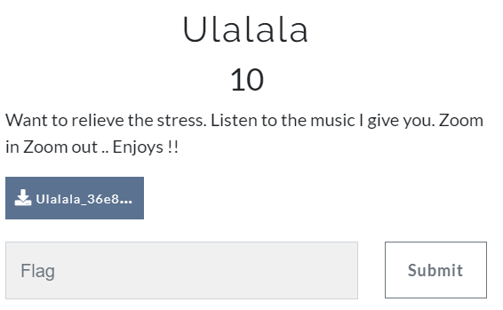

Next challenge also gives us another mp3. Without wasting our time, we open it by using Audacity and inspect it with spectrogram. Do it just like before.

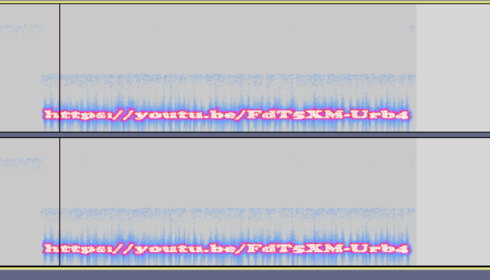

It gives us a YouTube link. <https://youtu.be/FdT5XM-Urb4> title flag.

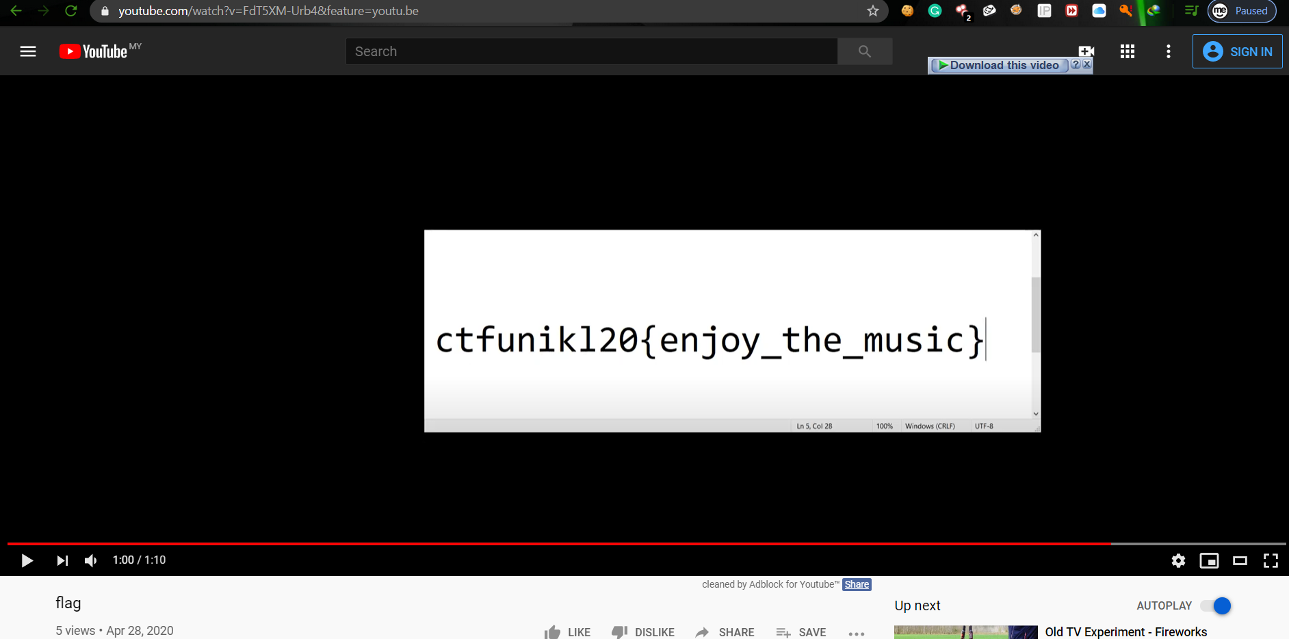



**ctfunikl20{enjoy_the_music}**

## SEE THE WORLD (40)

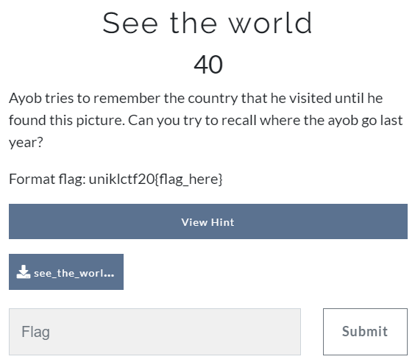

Let’s recall where Ayob go last year.

Download the Worldmaps.png

* Binwalk it shows many things inside it.

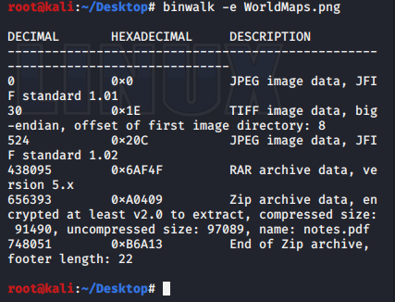

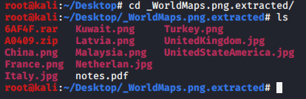

There are all the things you get. Try to unzip both “.rar” and “.zip” file. I try to Unzip “.zip” file, but it asked for password.

Unzip “.rar” gives a folder of flags. But “Netherland.jpg” seems interesting.

Its either misspelled or a hint. Still can’t get anything with binwalk. So, we tried “foremost”



The output folder gives us a pdf with a Morse code.

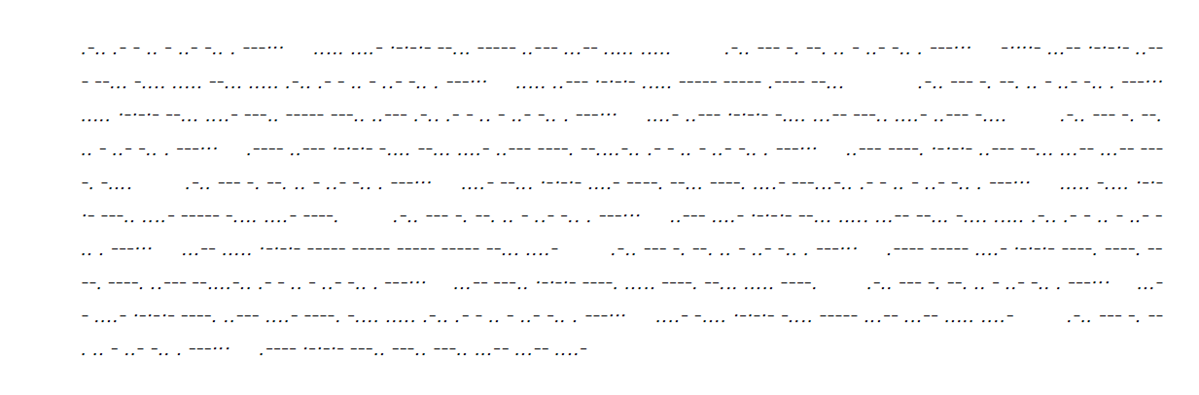

We try decoding it using CyberChef.

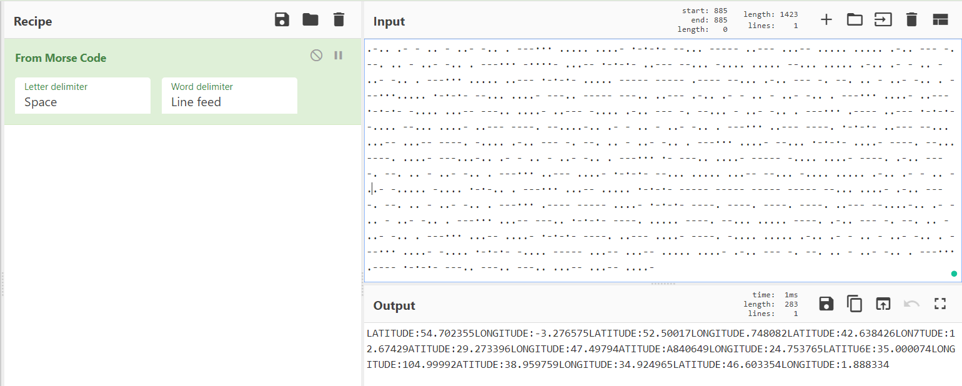

Here, the output. Gives us a longitude and latitude.

This the website I use.

* <https://www.latlong.net/Show-Latitude-Longitude.html>
* <https://gps-coordinates.org/coordinate-converter.php>



LATITUDE:54.702355, LONGITUDE:-3. T76575

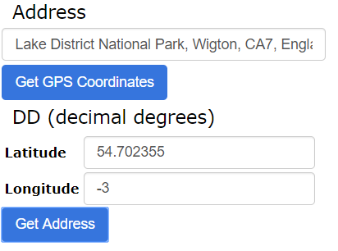

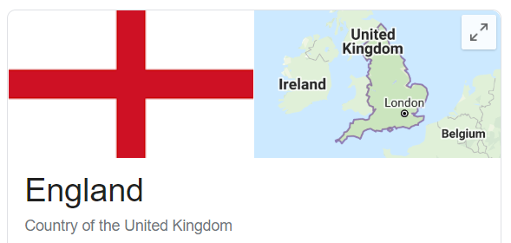

England is UK

LATITUDE:52.50017 LONGITUDE: 5.748082

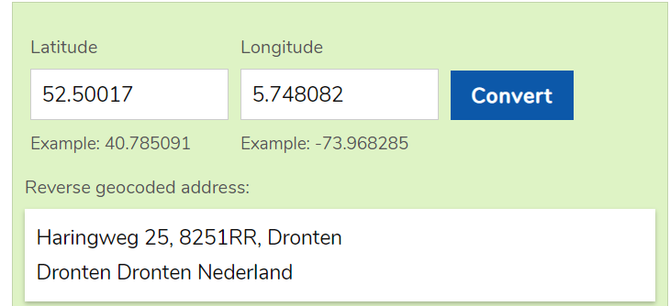

LATITUDE:42.638426, LONG ITUDE:12.67429

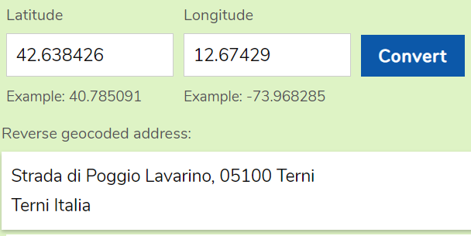

LATITUDE:29.273396, LONGITUDE:47.49794

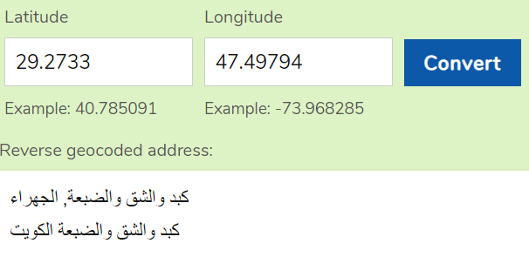

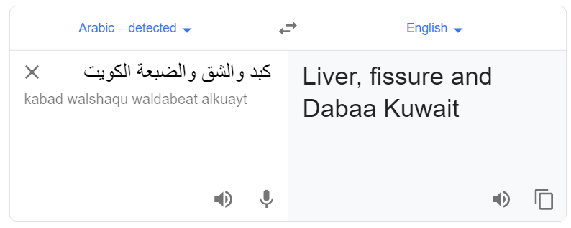

LATITUDE:56.840649, LONGITUDE:24.753765

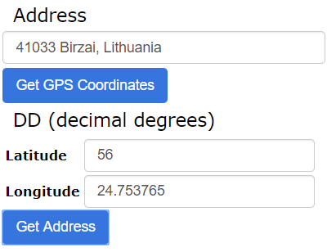

LATITU6E:35.000074, LONGITUDE:104.99992

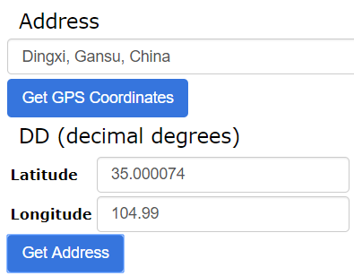

LATITUDE:38.959759, LONGITUDE:34.924965

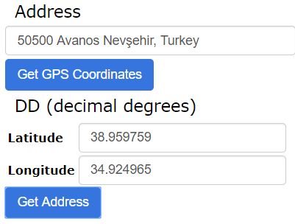

LATITUDE:46.603354, LONGITUDE:1.888334

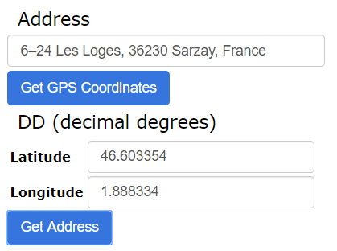

So, what do we get from all this Geography Class??

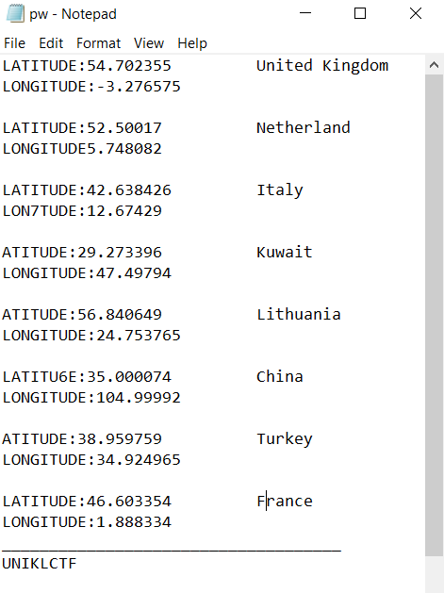

We try this as a password for “.zip” file.

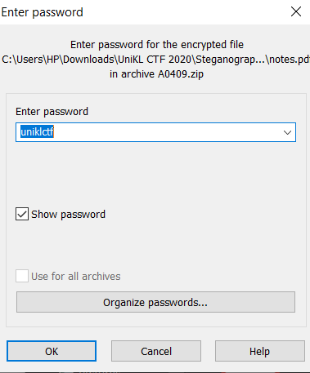

Good news, it is the password and we get “notes.pdf”

Bad news, it is another puzzle.



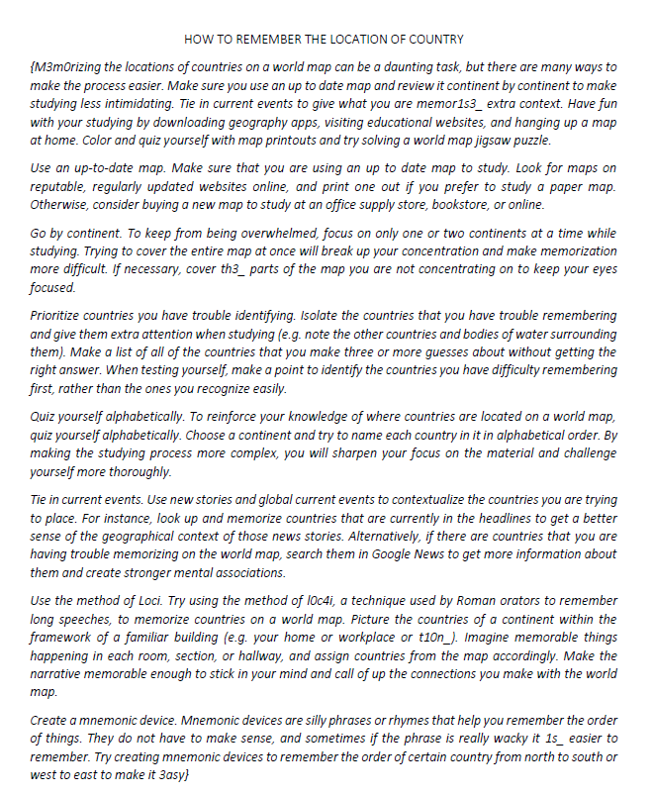

Reading through the passage, there is a few words seems interesting.

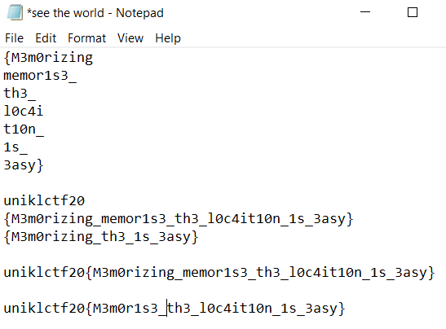

We tried to combine all possible flag then realised that “M3m0rising” and “memor1s3” just can’t work together. So, we decide to get each word divorce into two part where only the spelling combination with number were selected, “**M3m0**rising” and “memo**r1s3**” then we got them married. And here we come.



**uniklctf20{M3m0r1s3_th3_l0c4it10n_1s_3asy}**

# **FORENSIC**

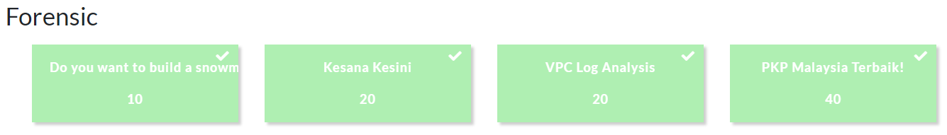

## DO YOU WANT TO BUILD A SNOWMAN? (10)

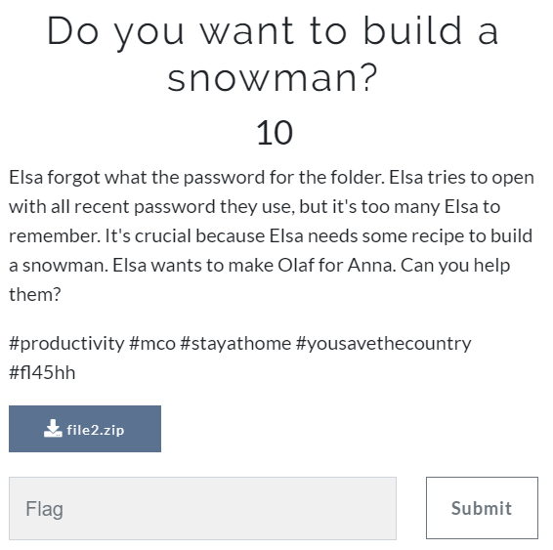

It is password protected file. We try to unlock it with online ZIP file password remover. (<https://passwordrecovery.io/zip-file-password-removal/>). In no time, we got the password.

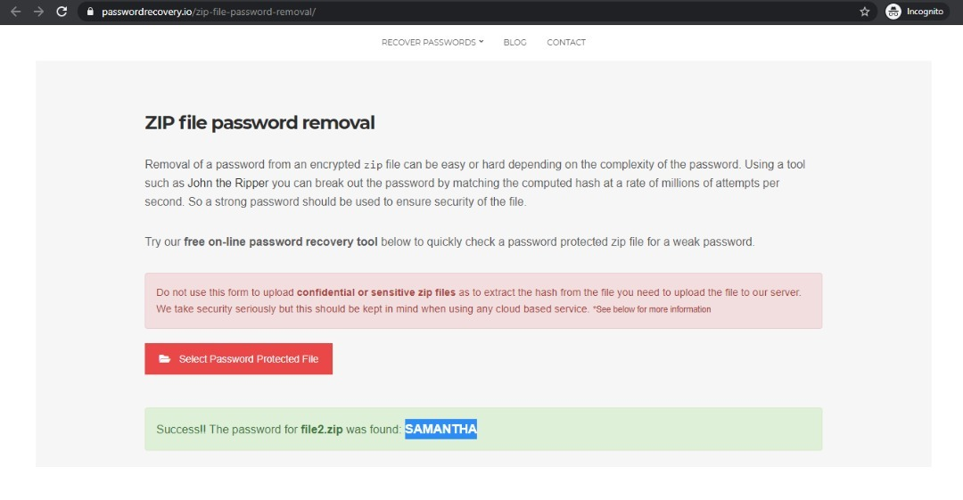



**uniklctf20{olaf_said_you_learn_something_during_mco}**

## KESANA KESINI (20)

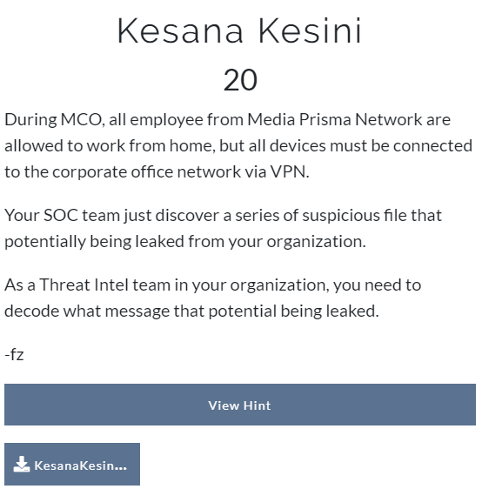

Download file “Kesana Kesini”

* Jurnal1.zip
* Jurnal2.zip

But each file is password protected zip.

So, we read, read, and read again the description.

It is about current situation is it?

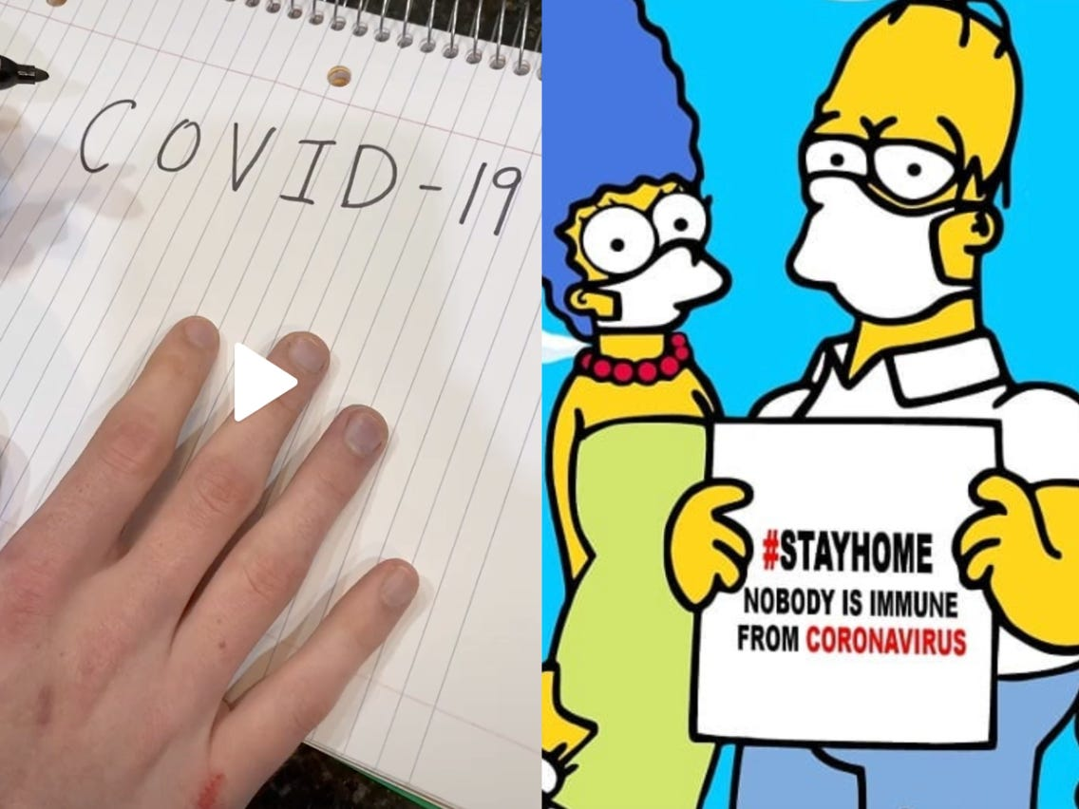

For “Jurnal1.zip” we get the password quite early which is “covid19”

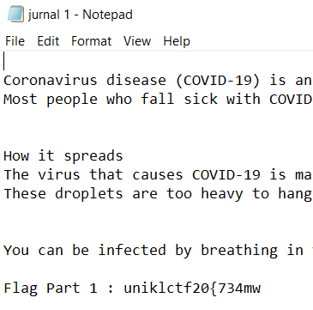

There is a flag part 1 in the “Jurnal1.txt”

So, we need to open “Jurnal2.zip” to get the rest of the flag.

But then we stuck at “Jurnal2.zip”

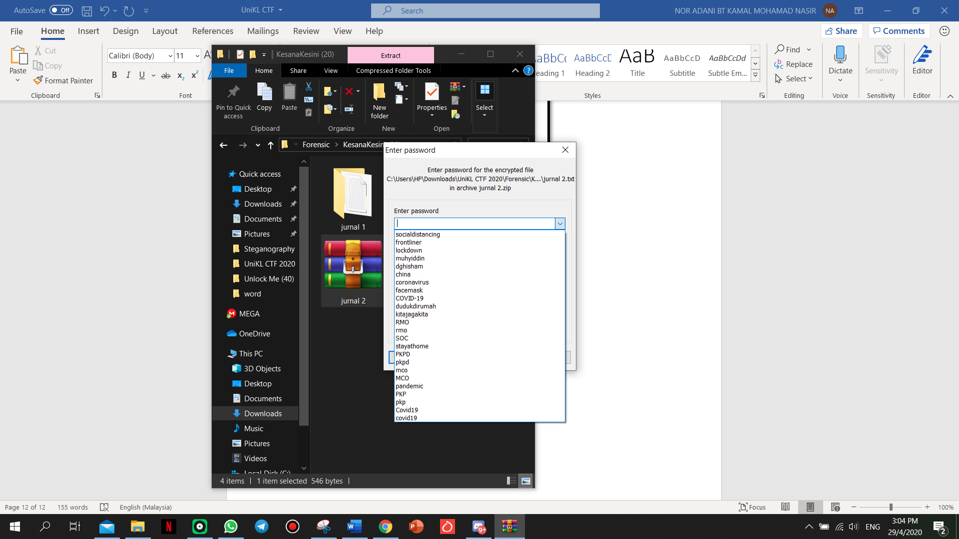

This is possible password that we try.

We looked and try so many “COVID-19” terms.

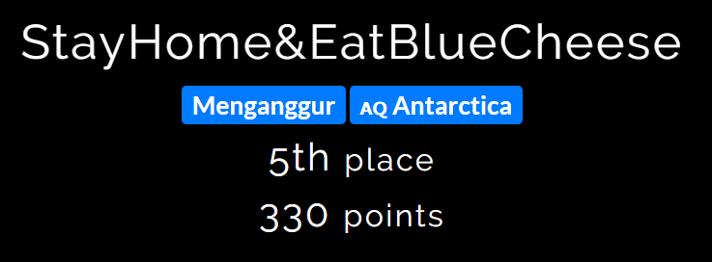

Thanks to Team_StayHome&EatBlueCheese for giving us another idea.

Until “stayhome” unlocked it for us.



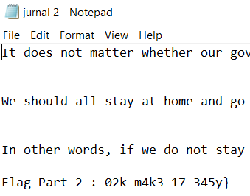



**uniklctf20{734mw02k_m4k3_17_345y}**

## VPC LOG ANALYSIS (20)

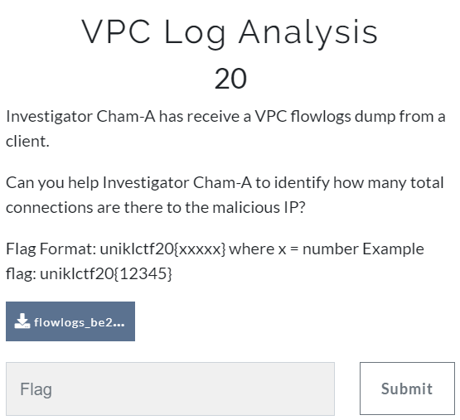

Here it is, 412 zip of a log dumps.



gunzip *.gz



This command will unzip and delete all “.gz” in the folder.

Next, I try to grep using this command:

grep -c <word> *.log

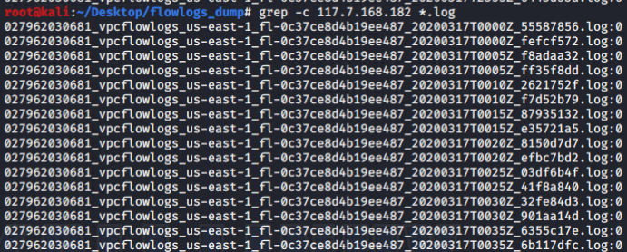

Figure 1 grep -c 117.7.168.182 *.log

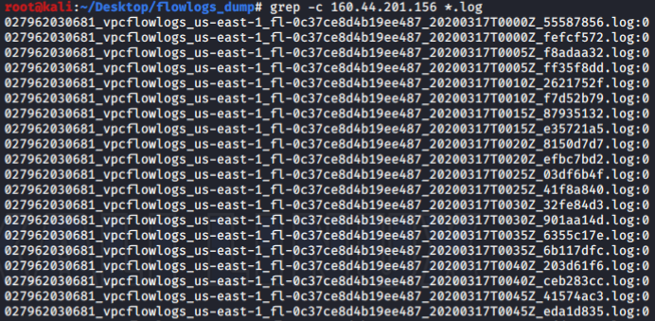

Figure 2 grep -c 160.44.201.156 *.log

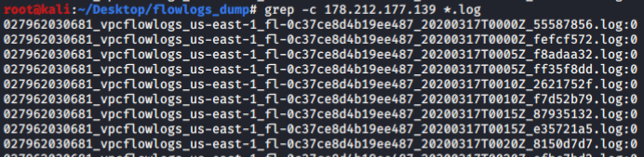

Figure 3 grep -c 178.212.177.139 *.log

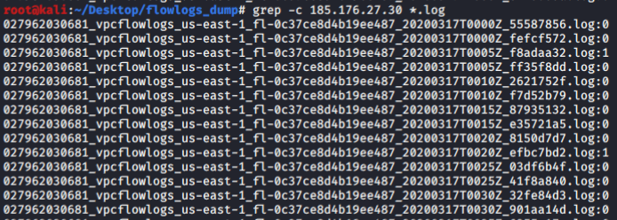

Figure 4 grep -c 185.176.27.30 *.log

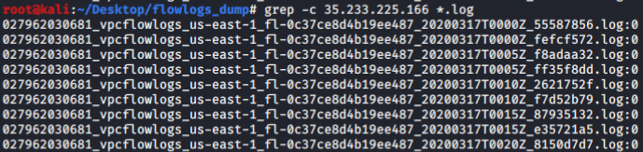

Figure 5 grep -c 35.233.225.166 *.log

But it is a disaster.



It gives a long (412 output) for every Malicious IP. And I need to count for 412 manually.

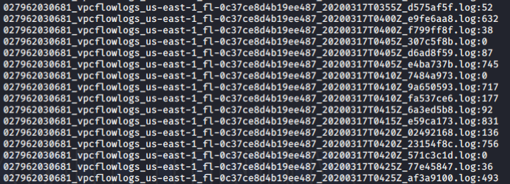

We repair the command to

grep -o -w <'malicious Ip'> *.log | wc -w

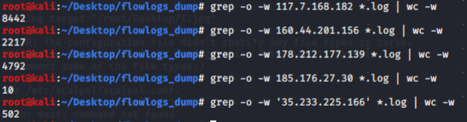

Okay so, it much easier. But still I want to make it easier.

grep -o -w '117.7.168.182\|160.44.201.156\|178.212.177.139\|185.176.27.30\|35.233.225.166' *.log | wc -w



FLAG





**uniklctf20{15963}**

## PKP MALAYSIA TERBAIK! (40)

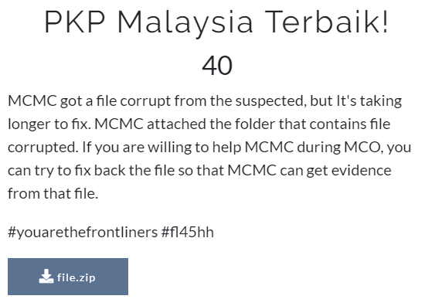

The downloaded file, give 4 part.

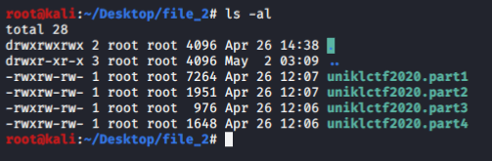

I try the “file” command to know what file is this.

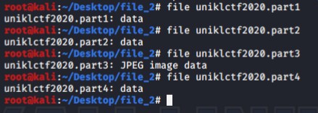

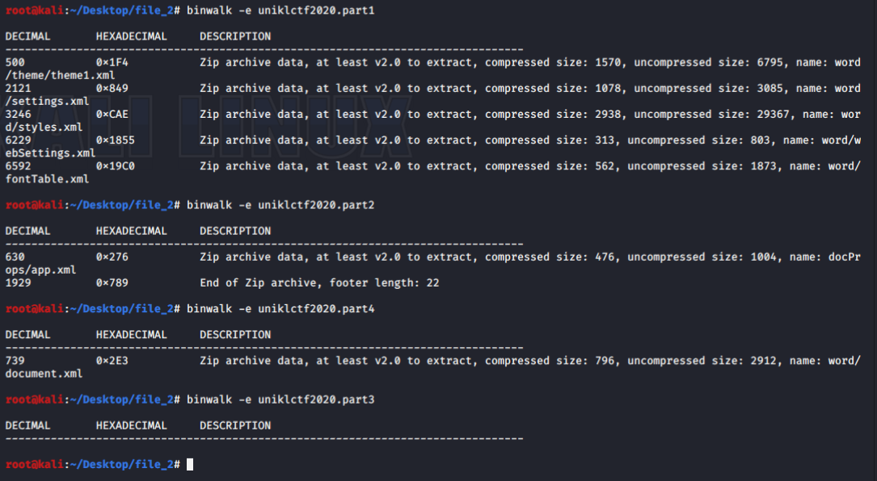

We “Binwalk” all the file. But seems like there is nothing in part3.

Open all the folder that we have extract give us a lot of “xml” file.



“uniklctf2020.part1” extracted folder. Open “settings.xml” give us one part of the flag.

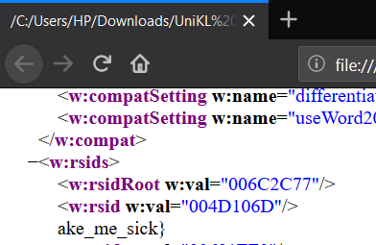

ake_me_sick}

“uniklctf2020.part2” extracted folder. Open “app.xml” give us another part of the flag.

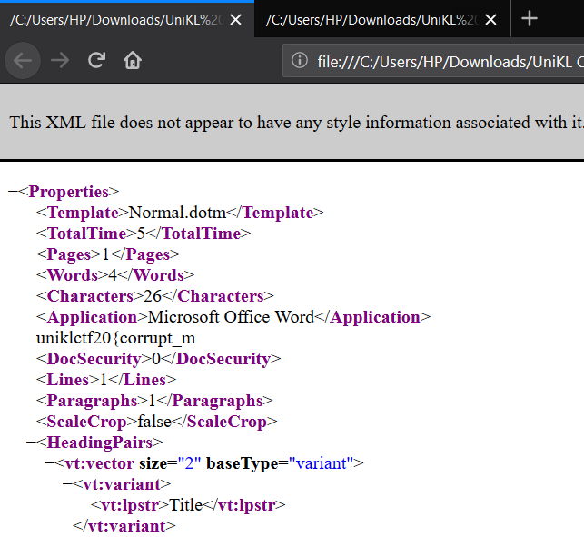

uniklctf20{corrupt_m



**uniklctf20{corrupt_make_me_sick}**

# **MISC**

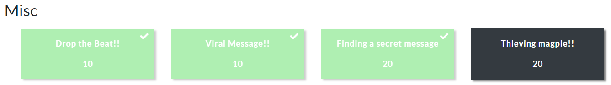

## DROP THE BEAT (10)

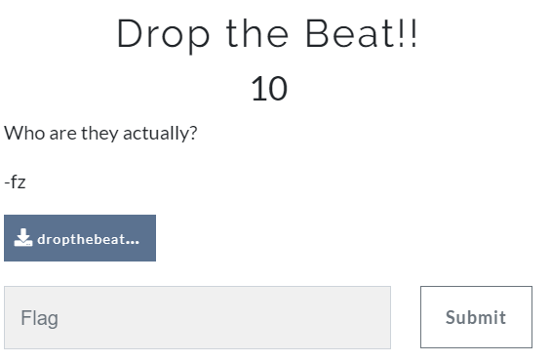

There is two same image that we downlaod from the file given.

But cksum for both file is difference.

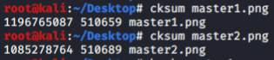

We try many tools, but we do not have anything.

Exiftool. Hexeditor, stegsolve, Binwalk, strings.

Do some googling and find these tools called “zsteg”

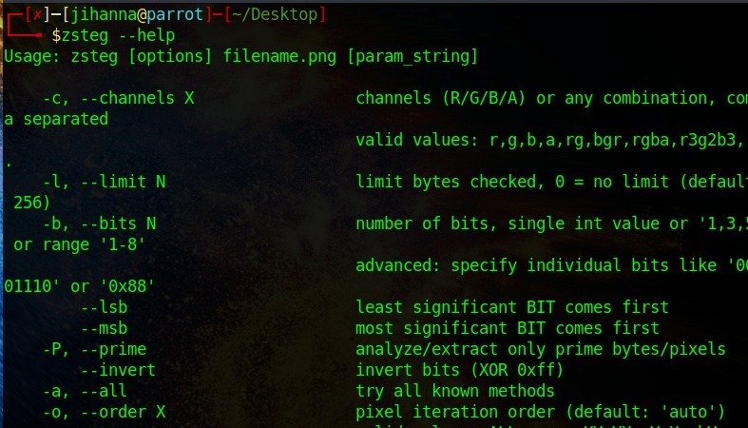

We just run (-a to try all known method.)

zsteg -a <image file>



And we get the passkey in the Master1.jpg (Passkey: whatwehavehere)

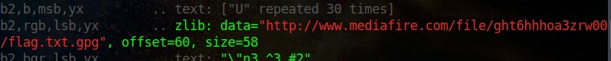

We get link in Master2.jpg (<http://www.mediafire.com/file/ght6hhhoa3zrw00/flag.txt.gpg>)

Download the file through link. And run command. Put the passphrase we found earlier.

gpg -d flag.txt.gpg

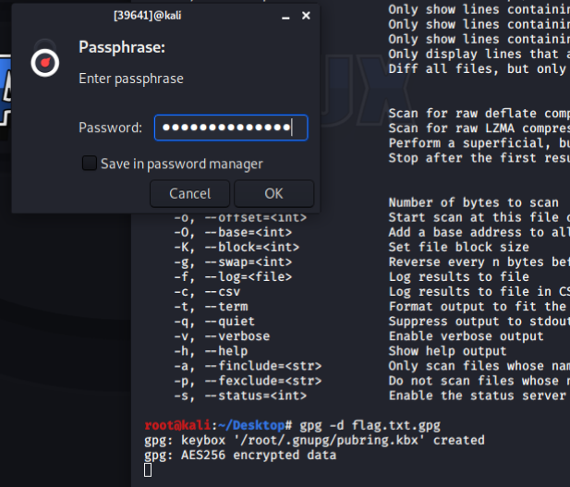

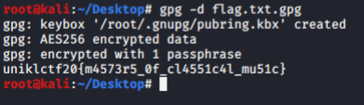



**uniklctf20{m4573r5_0f_cl4551c4l_mu51c}**

## VIRAL MESSAGE!! (10)

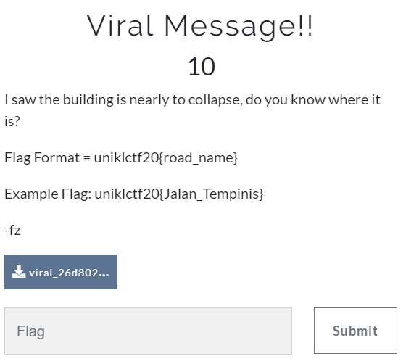

This is the picture that organiser give.

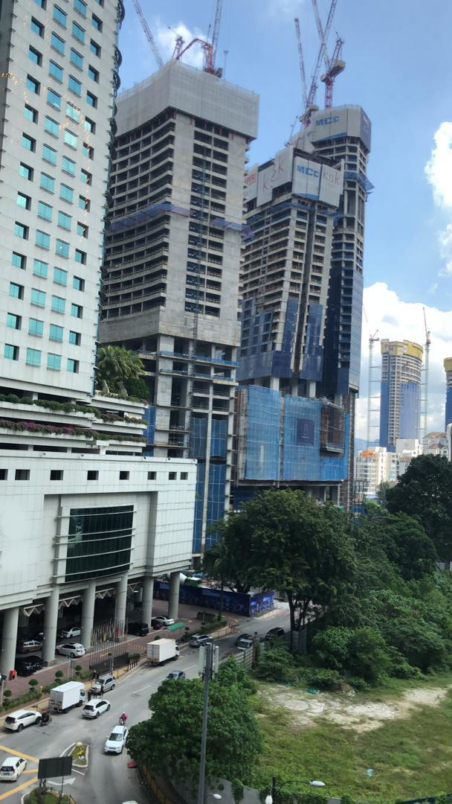

We knew this road is towards the Hotel Royale Chulan Kuala Lumpur.

Find the address for the hotel gives us the road name.

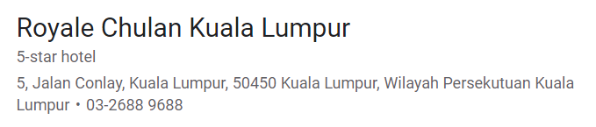



**uniklctf20{Jalan_Conlay}**

## FINDING A SECRET MESSAGE (20)

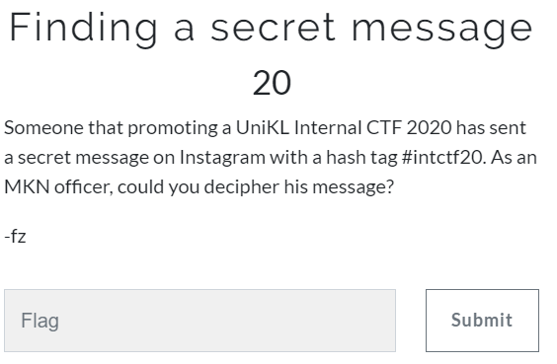

Open Instagram and search for #intctf20. Give us this as a result.

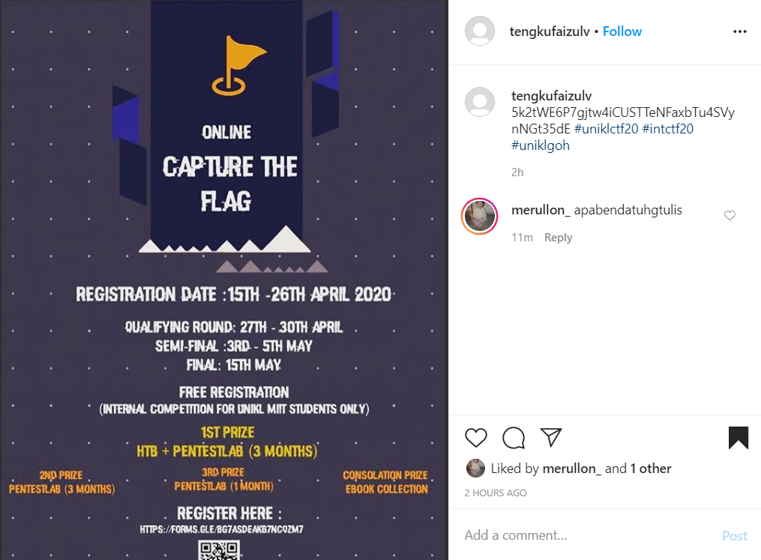

Copy the encrypt message and paste it into Cyber Chef. Let magic do the work.



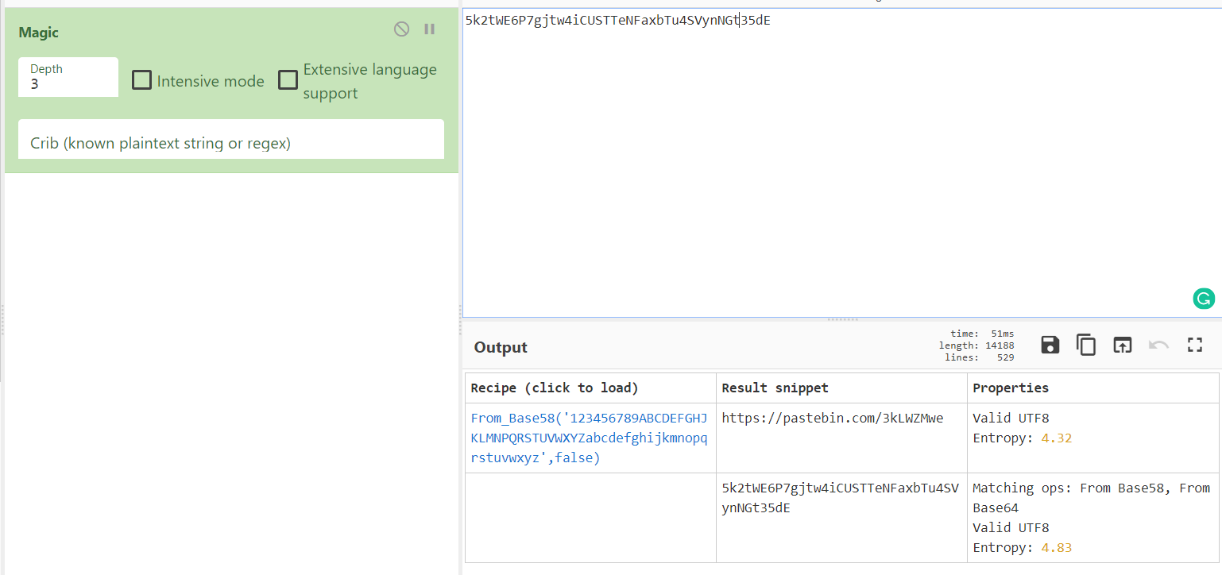

It give a link to paste bin (<https://pastebin.com/3kLWZMwe>). TA-DAA!!

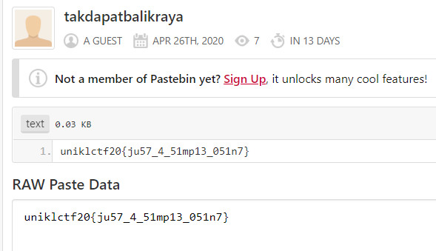



**uniklctf20{ju57_4_51mp13_051n7}**

# **CRYPTO**

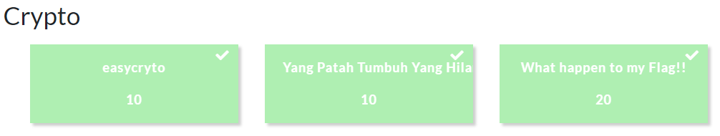

## EASYCRYPTO (10)

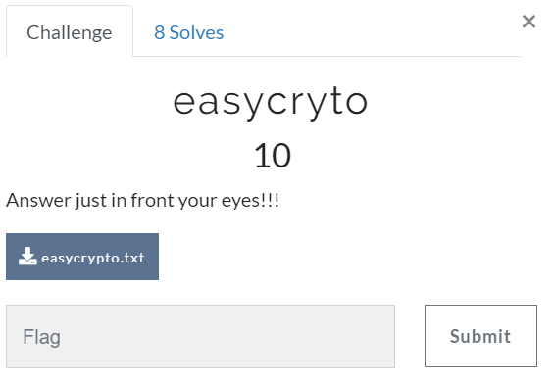

This is the text in the “easycrypto.txt”.

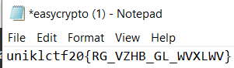

We encrypt it here: <https://cryptii.com/pipes/alphabetical-substitution>

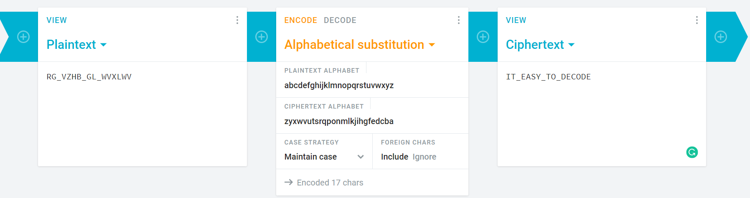



**uniklctf20{IT_EASY_TO_DECODE}**

## YANG PATAH TUMBUH YANG HILANG BERGANTI (10)

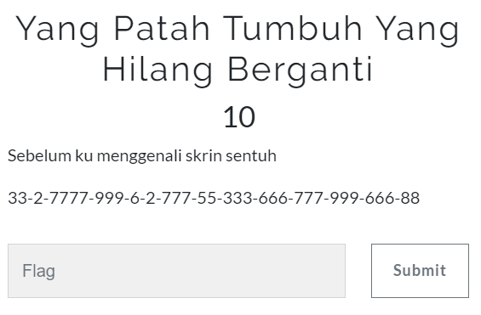

We google for phone touch pad and encrypt it.

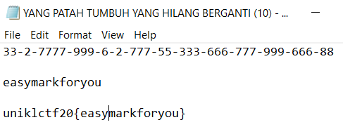

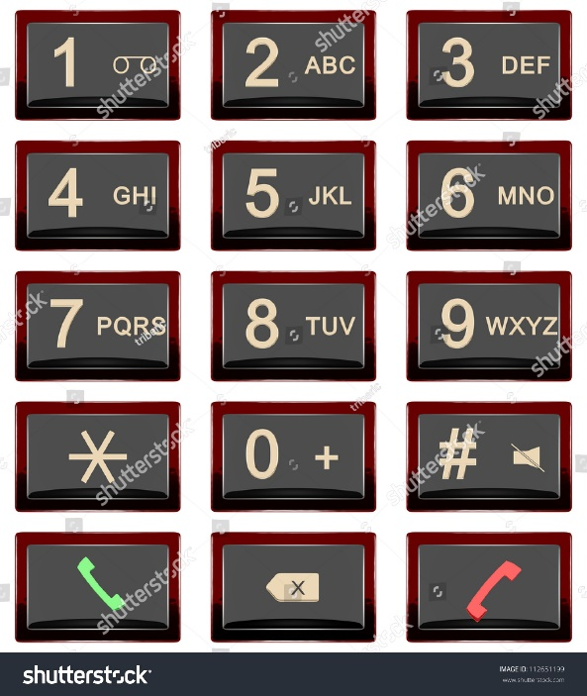



**uniklctf20{easymarkforyou}**

## WHAT HAPPEN TO MY FLAG (20)

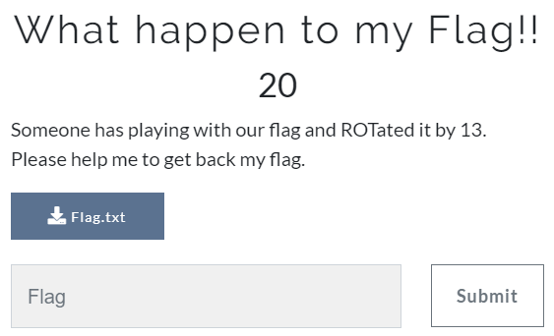

Download the Flag.txt.

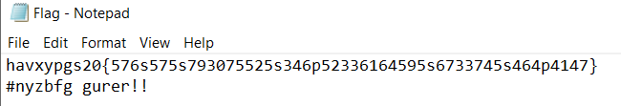

The hint given is ROT13.

Open Cyber Chef.

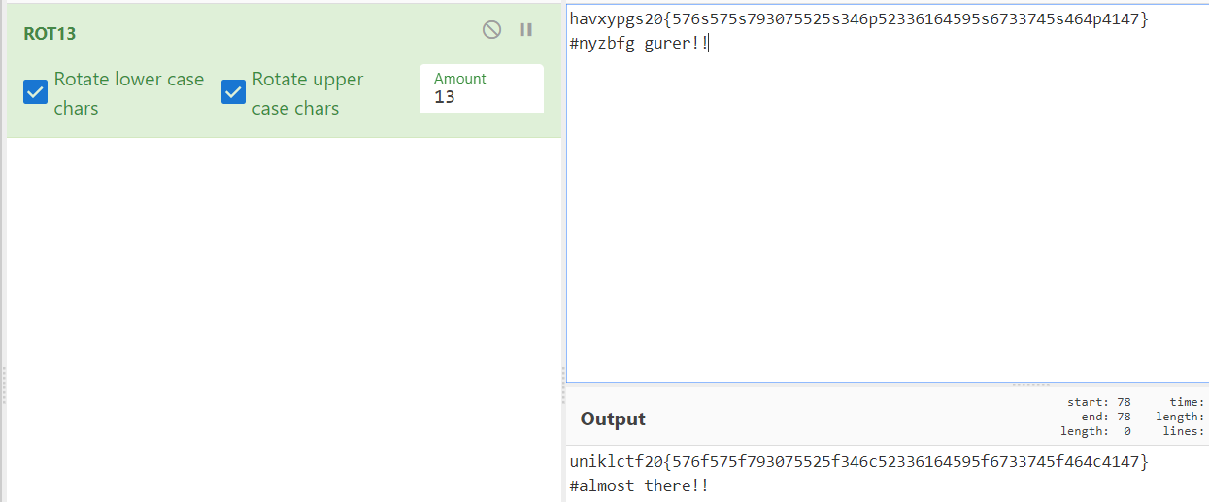

uniklctf20{576f575f793075525f346c52336164595f6733745f464c4147}

#almost there!!

But only half is decrypt.

We try all possible, UNTIL



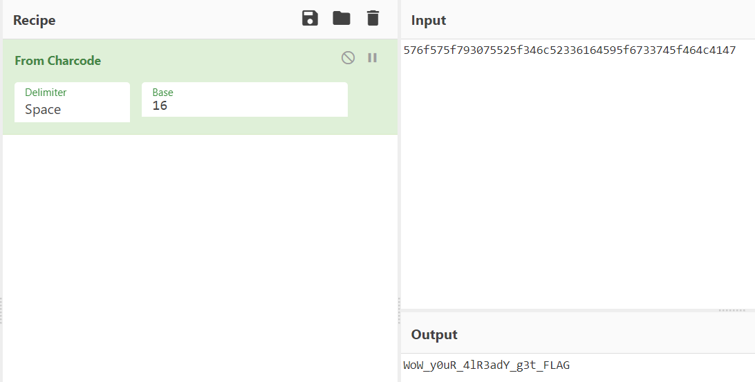



uniklctf20{WoW_y0uR_4lR3adY_g3t_FLAG}